**Activity 1 – Introduction to SQL**

**Exercise 1:**

Sql code:

SELECT * From tblappointment;

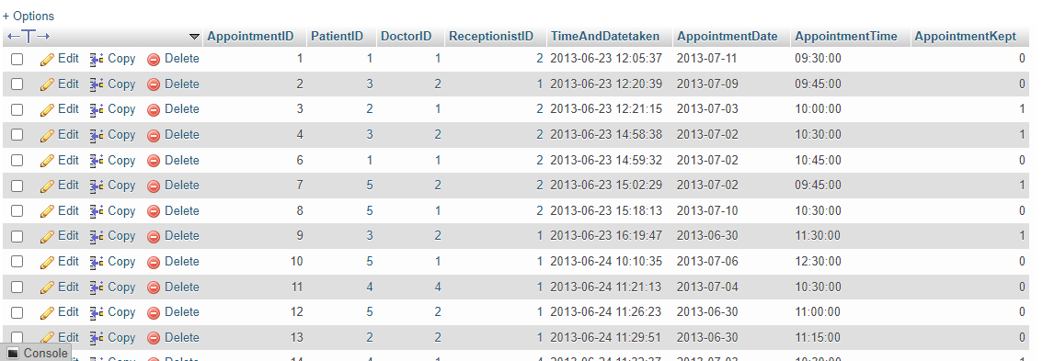

Total number of records: 84

**Exercise 2**

SELECT * FROM tbldoctors;

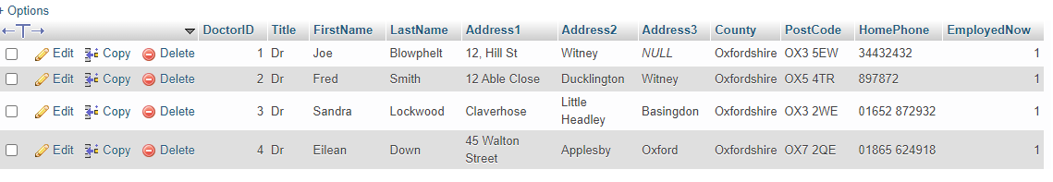

Total number of records: 4

SELECT * FROM tblpatient;

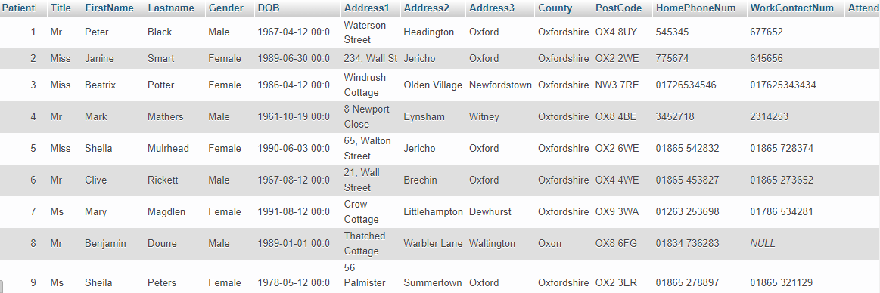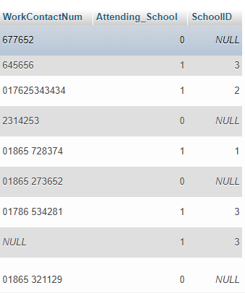

Total records: 25

SELECT * FROM tblreceptionist;

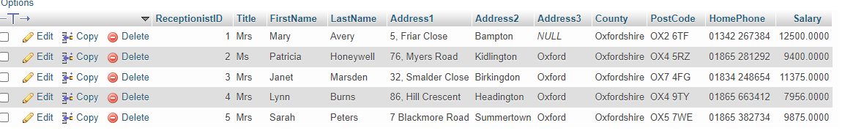

Total number of records: 5

**Exercise 3**

SELECT DISTINCT County FROM tblpatient;



**Exercise 4:**

SELECT DISTINCT Title FROM tblpatient:

